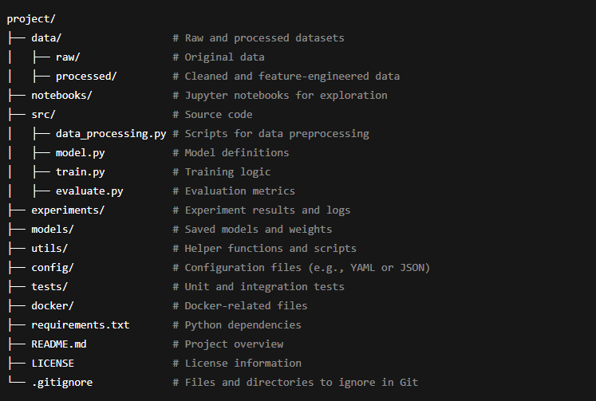

1. **data/**

* **Purpose**: To store datasets used in the project.
* **Subfolders**:
  + **raw/**: Original, untouched data files (e.g., .csv, .json, images).
  + **processed/**: Cleaned, transformed, or preprocessed datasets.
* **Best Practice**: Never modify files in raw/. Always save intermediate results in processed/.

**2. notebooks/**

* **Purpose**: For Jupyter notebooks used in experimentation and exploration.
* **Examples**:
  + 01_data_analysis.ipynb: Exploratory Data Analysis (EDA).
  + 02_model_trials.ipynb: Quick prototyping of models and ideas.

**3. src/**

* **Purpose**: Contains reusable, production-ready Python scripts.
* **Examples**:
  + data_processing.py: Scripts for data cleaning, splitting, and transformations.
  + model.py: Definitions of machine learning models.
  + train.py: Scripts for training models.
  + evaluate.py: Scripts to compute performance metrics.

**4. experiments/**

* **Purpose**: To store logs, results, and outputs of different experiments.
* **Examples**:
  + Hyperparameter tuning results.
  + Performance metrics comparison files.
* **Best Practice**: Use tools like MLflow or W&B to track experiments here.

**5. models/**

* **Purpose**: To store trained models, checkpoints, and weights.
* **Examples**:
  + random_forest.pkl: Serialized model file (e.g., using joblib or pickle).
  + model_v1.h5: TensorFlow or PyTorch model files.

**6. utils/**

* **Purpose**: Contains utility scripts for common tasks.
* **Examples**:
  + plotting.py: Functions for visualizing data and results.
  + metrics.py: Functions for computing evaluation metrics.
  + logger.py: Custom logging configurations.

**7. config/**

* **Purpose**: To store configuration files for parameters and settings.
* **Examples**:
  + config.yaml: Training hyperparameters, file paths, etc.
  + logging_config.json: Logging levels and formats.

**8. tests/**

* **Purpose**: Contains unit and integration tests to ensure code reliability.
* **Examples**:
  + test_data_processing.py: Tests for data transformation functions.
  + test_model.py: Tests for model creation and inference.

**9. docker/**

* **Purpose**: Contains Docker-related files for containerizing the project.
* **Examples**:
  + Dockerfile: Instructions to build the project’s Docker image.
  + docker-compose.yml: Setup for multi-container configurations.

**10. Root Files**

* **requirements.txt**: List of Python dependencies (e.g., pandas, scikit-learn).
* **README.md**: Project overview, setup instructions, and usage guide.
* **.gitignore**: Specifies files and folders Git should ignore (e.g., data/processed/, *.pkl).
* **LICENSE**: Specifies licensing terms for the project.